PROJECT SYNOPSIS

“E-STUDY ZONE”

SYNOPSIS SUBMITTED FOR THE PARTIAL FULFILMENT OF THE
REQUIREMENT FOR THE BACHLOR OF TECHNOLOGY

SUBMITTED TO
“College Name”
City Name

SUBMITTED BY:
STUDENT NAME

(College Enrolment Number- XXXXXXX )
2023-2027



Under the Guidance of
Er. Pushkar Singh
Consultant

SOFTPRO INDIA COMPUTER TECHNOLOGIES (P) LTD

INTRODUCTION

The client who wants to promote an innovative concept which can bring Learner and Trainer on a common platform so that they can share their knowledge.
This is web-based portal should which is broadly categorize users of the website in to two categories – learner and trainer.
‘Learner’ is the one who wants to gather knowledge and ‘Trainer’ is the one who will provide information. It is required to build a portal that will be used worldwide. The learner should be able to mention his area(s) on which he wants study material and the trainer should be able to mention his expertise his area(s) of excellence according to which he can provide study material to the learner. The trainer should be able to store his study material in the online library of the website.

There should be an administrator page where the administrator would have access to all the information stored in any table.
The e-study zone is a Web based portal that will be common place for all learners and trainers. The learner and trainer will register themselves on the site for further proceedings. The learner will mention the topic upon which he wants to query whose list will be maintained. The trainer will enter his specializations and expertise in various fields. The trainers and learners will get the unique id by which he will login. According to the topics mentioned by the learner, a list of trainers will be shown to him who will have expertise in the fields mentioned by the learner.

OBJECTIVE

- To provide common place for learner and trainer.

- To create portal where people can share information & knowledge in an effective and efficient manner.

- Accurate and fast information access

- Improved tutorials.

- User friendly.

Scope

- Provides relevant, quality study materials over various technologies.

- single platform

- Virtual environment.

- Address lots of issues and get solutions.

- Opportunity for students and teachers.

- Building foundation.

EXISTING SYSTEM

- Retrieving of records is difficult
- No options of giving suggestions by both trainers and learners
- Searching is time consuming
- Processing speed become slow
- Insecure data
- There is no facility for securing personal information of visitors and users

PROPOSED SYSTEM

- covered various languages contents
- various security checks by administrator
- user friendly website
- easy query resolving
- quick and advanced search by trainers
- easy explanation and easy availability of the material

The Challenges

Following challenges were encountered during the website development: -

- Query Resolving Process of Trainer.
- Quick and Advanced Searching of study material by Trainer
- Handling the Learning Codes and Expertise Area of Learner and Trainer.
- Administrator’s work handling.

Benefits

The points discussed above and the system formed assuming these to happen, future scope of the system is fair:

- This project was prepared keeping in mind that this system will be used by many users and very effective communication system is used in this project. But is no of users will increased in future then with a very few enhancements it will be able to work properly.

- Increase width and size. So whenever required these operations and changes can be easily applied.

- New contents and new learning area and can be added by applying little work or whenever it will be required in future.

- New features and functions can be added easily by understanding the system.

ABOUT THE PROJECT
The proposed project, named E-Study Zone, aims to revolutionize the way learners and trainers connect and share knowledge globally. This web-based portal categorizes users into two main groups: learners, seeking knowledge, and trainers, ready to impart expertise. The platform allows learners to specify their desired study topics, while trainers can showcase their specializations, storing study materials in the online library. Users receive unique IDs for login. An administrator page ensures comprehensive access to stored information. The project's objective is to provide a common ground for effective knowledge exchange, offering accurate and fast information access, improved tutorials, and user-friendly interactions. The scope includes a single platform offering relevant study materials across various technologies, creating a virtual environment for issue resolution, and providing opportunities for both students and teachers. The proposed system addresses existing challenges, introducing security checks, user-friendly interfaces, and efficient search functionalities for an enhanced e-learning experience. The analysis steps of project are given below: -
- Feasibility Study

Feasibility study is the measure of how beneficial or practical the development of an information system will be to an organization. The Feasibility analysis is a cross life cycle activity and should be continuously performed throughout the system life cycle.

- Operational Feasibility: -

The web-based matrimonial application aims to provide users with convenient access to a comprehensive and user-friendly platform for finding life partners. The operational feasibility is evident in the streamlined information sharing and selection processes. Users will benefit from reduced effort in managing their profiles, and the system's efficient handling of large databases ensures data integrity and avoids record loss. Overall, the system is designed to enhance user satisfaction and provide a seamless experience for end-users.

- Technical Feasibility: -

For the design and development of the system, several software products have been accommodated.
- Database design – Utilizing MongoDb for efficient and secure data storage.
- Interface design – Incorporating HTML, CSS, JavaScript, React JS ,and Bootstrap for a visually appealing and responsive user interface.
- Coding – Employing Node JS with Express framework, ensuring a robust and scalable system.

The technology (Node JS with Express framework) has enough efficiency for the development of the system. Therefore, the project is technically feasible.

- Schedule Feasibility: -

The duration of time required for the project has been planned appropriately and it is the same as the duration of time expected by the client. Therefore the portal can be delivered to the client within the expected time duration, satisfying the client. Hence the project is feasible in scheduling.

- Economic Feasibility: -

According to the resources available and the project scheduling process it is estimated that the expenses allocated for the web application to be developed, by the client is sufficient enough. Hence the economical factor has been considered feasible.

- Project Planning & Scheduling: -

Planning is very important part of any software development. In the planning phase, we decide which features are to be included in the system to make a good system, how much time do we need to complete the project, what will the cost of the system etc…
A Software Life Cycle or software process is a series of identifiable stages that a software product undergoes during its development. A software product development effort usually starts with a project identification and selection stage and then requirements analysis; design, coding, testing, implementation and maintenance are undertaken.
A life cycle model identifies all the activities required to develop and maintain a software product and establishes a precedence ordering among the different activities.
The various phases of Software Development Life Cycle-

- Requirement Analysis
- System Design
- Coding
- Testing
- Implementation

SOFTWARE REQUIREMENT FOR DEVELOPMENT
User Interface Designing | HTML5, CSS3, Java Script, Bootstrap, React JS
Framework | Node JS with Express framework
Database | MongoDb
IDE | VS Code

MODULES

User Information Management

- Login Manager
- Learner Advance Profile
- Trainer Advance Profile
- Request Module

Query Management

- Query Manager
- Archive Collection
- Download Material
- Suggestion Box
- Administrator

Login Manager

The Login Manager is responsible for handling login related information of user. It has user friendly GUI interface which provides all the required information with minimum efforts.
The Login Manager has the responsibility to allow only authenticated users to login to the website. It keeps check over the entry of the user. It provides flexibility to the users even in the case when the user forgets his password. However, the module has no provision to display the password if the user forgets his password for security reasons.
The module consists of procedures to handle the storage, updation and deletion of records of a particular userid. It also consists of methods for authenticating the user. The authentication can be by matching the password against user id or by matching the hint question and hint answer. It is also responsible for fetching the hint question if the user forgets the password.

Basic Profile

Basic profile deals with profile creation of the user during his/her registration time. Users can be either be Learner or trainer.
It is like a form which is going to be filled with personal details by the users. This information can be filled by the user during his login detail entries. Basic profile information can be viewed by the user i.e., learner or trainer in the form of basic profile after entering to their homepage. While reaching to the homepage learner and trainer can view their basic information detail and can edit their personal details according to their situation.

Learner Advance Profile

This advance profile is responsible for saving the entries given by the learner according to his learning interest area. Learning area is that area or part in which learner want to query to the trainer and request for study materials in that particular area. There are more than 100 learning area where learner shows his interest and adopt for more than one learning area and will also tell his level in that learning area i.e his grading in particular subject. Their remarks will also be welcomed. All the learning area will be related to the IT- Technology fields. According to this learning area the expertise trainer will be allotted to the learner.

Request Module

This module is responsible for sending request by the learner to the trainer whom he want to handshake or attached so that learner will get his desired material. By just clicking to the request button his request will be forwarded to the requested trainer. Then if trainer will accept his request, then that learner will attach to the learner. Through this process material will be requested and material will be sent by the trainer to the learner.

Download Material Module

This module is responsible for downloading material which is given by the trainer to the learner. According to that requirement which is given by the learner to the trainer will provide material to the learner by providing him download button. From that download button learner will download the material.

Trainer Advance Profile

This advance profile is responsible for saving the entries given by the Trainer according to his Expertization area. Expertization area is that area in which trainer has command. In this particular area or subject trainer is considered to have done his mastery. There are more than 100 expertization area and trainer will opt for more than one expertise area. According to his expertization area he will be providing the study material to the learner when learner interest area and trainer expertization area will be matched. All the learning area will be related to the IT- Technology fields.

Query Manager

Learner Query Management

This module deals with management of queries given by the learner to the trainer according to the learning area of learner and expertization area of the trainer. After handshaking done between these two entities learner will fire his query to the attached trainer. All learners Queries details will be maintained in the database.

Trainer Query Management

This module deals with management of queries by the trainers. Learner will ask the queries to the trainer and trainer has to answer that query either replying him by telling queries status like resolved and unresolved and if queries are solved then set the status resolved and then providing study material to the learner .

Suggestion box

This module is responsible for welcoming or taking all the suggestions given by the learner and trainer. We can consider it like feedback is taking from learner and trainer. Their suggestions can only be viewed by the Administrator not by any other learner and trainer.

Administrator

Administrator will be the person who will have full control over the websites. He has power to view all users, all suggestions, all queries and all materials stored in trainer library. He has power to delete the users, suggestions, queries which are not meaningful.
Administrator will directly interact with the all the table that are used in project admin can perform various information on those table admin works as a controller that control over all project.

data flow diagram

Context Level Diagram

E-Study Zone
LEARNER
TRAINER
ADMINISTRATOR
Registration request
Login
Confirmation/Denial
Registration request
Login
Confirmation/Denial
Study material
Study material
Request
L / T information

ER-DIAGRAM

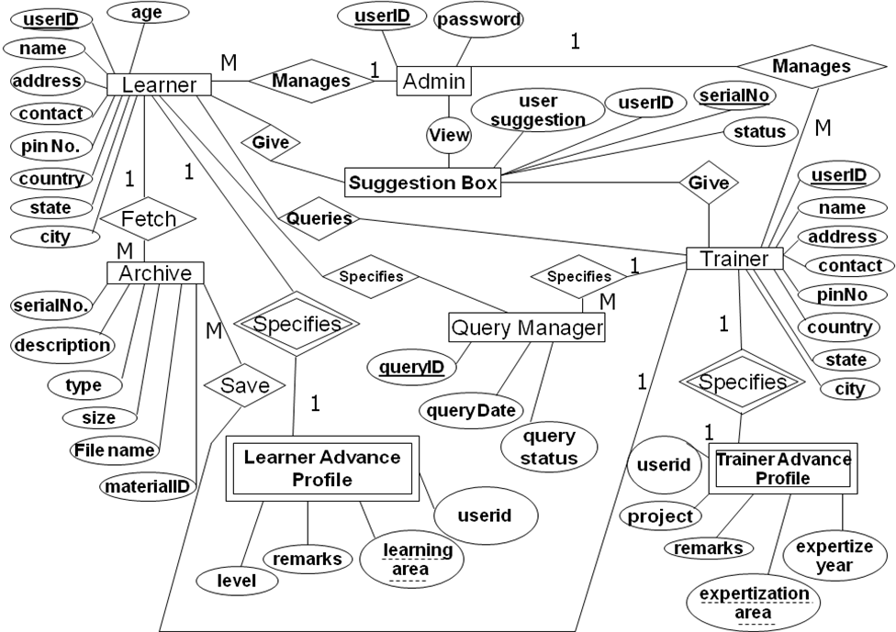
1
M
1
M
1
M
1
M
1
M

FUTURE SCOPE OF PROJECT

The future scope of the E-Study Zone project is both expansive and dynamic, envisioning continual enhancements and innovations to further enrich the learning and teaching experience for users worldwide. As technology evolves, the platform will adapt, incorporating emerging trends such as artificial intelligence and machine learning to personalize the learning journey. The introduction of collaborative features, including discussion forums, group study sessions, and interactive quizzes, will foster a sense of community among learners and trainers. Integration with virtual reality and augmented reality technologies may provide immersive educational experiences, enhancing comprehension and engagement.
To extend its global reach, the platform will explore language translation capabilities, breaking down linguistic barriers and ensuring accessibility for a diverse user base. The future iterations of E-Study Zone will also prioritize mobile compatibility and app development, facilitating on-the-go learning experiences for users who prefer accessing educational content through their smartphones or tablets.
Additionally, the project aims to establish partnerships with educational institutions, industry experts, and organizations, fostering a network of collaborative knowledge sharing. Gamification elements may be incorporated to make the learning process more engaging and enjoyable. The inclusion of real-time analytics and progress tracking features will empower both learners and trainers to monitor and optimize their educational journeys.
Continuous security upgrades and adherence to privacy standards will remain paramount, ensuring the confidentiality and safety of user data. Ultimately, the future scope of E-Study Zone envisions a comprehensive and adaptive e-learning ecosystem that not only keeps pace with technological advancements but also leads the way in shaping the future of online education by fostering a global community of learners and educators.

